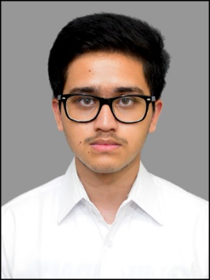 

Programmer Analyst Trainee

Email ID: 2370752@cognizant.comMobile: +919674959048

Address: Stanza Living Conway House, 1/299, Thalambur Rd, Navalur, Chennai, Tamil Nadu-603103

LinkedIn: https://www.linkedin.com/in/sankarshan-kar-a6bb97269

**CAREER OBJECTIVE**

Looking forward to contributing to projects and help the organization succeed by utilizing my skills and dedication. Eager to support team efforts and grow within the company.

**WORK EXPERIENCE**

**Programmer Analyst Trainee | Oct 2024 – Present**

Currently undergoing training program in Cyber Security where I’m learning Java, Python, programming, Integrated Threat Management (ITM) courses, gaining strong core and technical knowledge in these courses.

**ACADEMIC QUALIFICATION**

* **Kalinga Institute of Industrial Technology (KIIT), Bhubaneswar.**

B.Tech, Computer Science and Engineering | Sept 2020 –Sept 2024 | CGPA – 7.87

* **Delhi Public School, Ruby Park, Kolkata.**

12th | 2020 | 77.1%

* **N St Mathew’s Public School, Vijayawada.**

10th | 2018 | 90.2 %.

**PROFESSIONAL SKILLS**

* Programming skills known: C, C++, Python, SQL, JAVA, JavaScript, Go.
* Technology skills known: TensorFlow, Django, React.
* Adapting to new environment.
* Ability to learn new things.
* Ability to work independently or as a part of a team.
* Good at oral and written communication

**PROJECT WORKS**

* **Identifying Different Types of Brain Tumours using Deep Neural Networks.**
* Utilized big datasets of MRI data to train neural networks to a high accuracy.
* Implemented multiple different types of Convolutional Neural Networks (CNNs) using TensorFlow to find out which model produces the most accurate results.
* **LLM Text Detector.**
* Implemented a LLM Text Detector using the BERT model to differentiate LLM generated text or human written text.
* Used Django to create an API to easily access the model.

**PERSONAL DETAILS**

* Languages known : English, Bengali, Hindi.
* Domain Interests : Programming, Machine Learning, Cyber Security.
* Hobbies : Video games, Football.